Молдавский Государственный Университет

Факультет Математики и Информатики

Специальность: Прикладная Информатика

Лабораторная работа №3

Преподаватель: Бодруг С  
Студент: Кадомцев А  
группа IA1902

Кишинёв 2021

**Задание №1:**

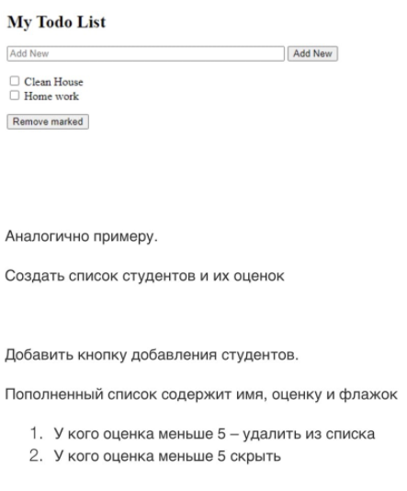

**Выполнение:**

<!DOCTYPE html>

<html>

<head>

<title>Cadomtev Alex Homework</title>

<script src = "https://ajax.googleapis.com/ajax/libs/angularjs/1.3.14/angular.min.js">

</script>

</head>

<body ng-app="myApp" ng-controller="todoCtrl">

<h2>Students</h2>

<form ng-submit="todoAdd()">

<input type="text" ng-model="Name" size="30" placeholder="Name">

<input type="number" min="1" max="10" ng-model="Mark" size="10" placeholder="Mark">

<input type="submit" value="Add New Student">

</form>

<div ng-repeat="x in todoList">

<input type="checkbox" ng-model="x.done"> <span ng-bind="x.Name"></span>, mark:<span ng-bind="x.Mark"></span>

</div>

<p><button ng-click="remove()">Remove marked</button></p>

<p><button ng-click="remove_neg()">Remove students with negative mark</button></p>

<script>

var app = angular.module('myApp', []);

app.controller('todoCtrl', function($scope) {

$scope.todoList = [{Name:'John', Mark: '8', done:false}];

$scope.todoAdd = function() {

$scope.todoList.push({Name:$scope.Name, Mark:$scope.Mark, done:false});

$scope.Name = "";

$scope.Mark = "";

};

$scope.remove = function() {

var oldList = $scope.todoList;

$scope.todoList = [];

angular.forEach(oldList, function(x) {

if (!x.done) $scope.todoList.push(x);

});

};

$scope.remove_neg = function() {

var oldList = $scope.todoList;

$scope.todoList = [];

angular.forEach(oldList, function(x) {

if (x.Mark >= 5) $scope.todoList.push(x);

});

};

});

</script>

</body>

</html>

**Результат:**

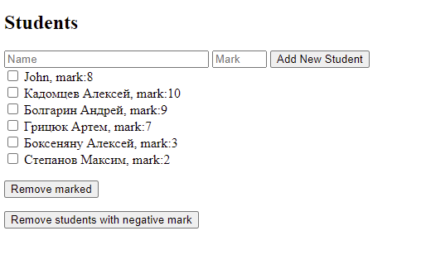

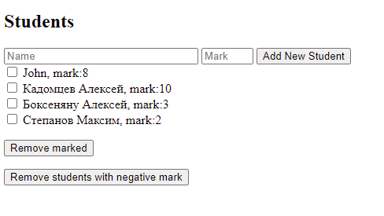

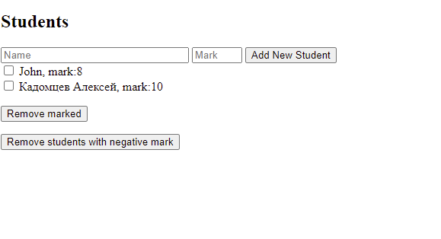

**Задание №2**

Создать формуляр - для оформления на работу  
  
Фамилия *  
  
Имя*  
  
Дата рождения*  
  
Формат dd month yyyy  
  
Проверка: возраст в пределах 18 – 70  
  
Флажок пол м/ж*  
  
*Образование  
  
Радиокнопки среднее, высшее, мастерат, доктор  
  
*Отдел  
  
Список селект: кадры, программирование, бухгалтерия  
  
Предполагаемая зарплата ......................  
  
Проверка: если зарплата в интервале 5000 -20000  
  
Активизируются кнопки ОК и ОТКАТ  
  
Если нажать на ОК -выдаетя информация из всех полей  
  
Если нажать на кнопку откат, то очищаются все поля

**Выполнение:**

<!DOCTYPE html>

<html>

<script src="https://ajax.googleapis.com/ajax/libs/angularjs/1.6.9/angular.min.js"></script>

<body>

<h1>Формуляр приема на работу</h1>

<div ng-app = "mainApp" ng-controller = "Controller">

<form name="myForm" novalidate>

<table border = "0">

<tr>

<td>Enter first name:</td>

<td><input type = "text" ng-model = "firstName" required></td>

</tr>

<tr>

<td>Enter last name: </td>

<td><input type = "text" ng-model = "lastName" required></td>

</tr>

<tr>

<td>Enter date of birth: </td>

<td><input type="datetime-local" ng-model="date"></td>

</tr>

<tr>

<td><form>

Click if genderis male:</td>

<td><input type="checkbox" ng-model="myVar">

</form></td>

</tr>

<tr>

<td><form>

Choose education:</td>

<td><input type="radio" ng-model="myEd" value="secondary">Secondary

<input type="radio" ng-model="myEd" value="higher">Higher

<input type="radio" ng-model="myEd" value="master">Master

<input type="radio" ng-model="myEd" value="doctor">Doctor

</form></td>

</tr>

<tr>

<td>Department:</td>

<td><select ng-model="dep" required>

<option ng-repeat="x in department">{{x}}</option>

</select></td>

</tr>

<tr>

<td>Salary:</td>

<td><input type="currency" ng-model="salary" required></td>

</tr>

</table>

<input type="submit" ng-click="myFunc()" ng-disabled="salary<=4999 || salary>=20000" >

<button ng-click="reset()">Reset!</button><br>

</form>

<br/>

<div ng-show="infoForm">

<table border = "0">

<tr>

<td>Name: </td><td>{{firstName + " " + lastName}}</td>

</tr>

<tr>

<td>Date of birth: </td><td>{{date | date : "dd MMMM y"}}

</td>

</tr>

<tr>

<td>Age: </td>

<td>{{a=(today | date : "yyyy") - (date | date : "yyyy")}}</td>

<td><p ng-show="a < 18">You must be over 18 years old.</p>

<p ng-show="a > 65">You must be under 65 years old.</p>

</td>

</tr>

<tr><td>Gender:</td>

<td><p ng-show="myVar">Male</p>

<p ng-show="!myVar">Female</p></td>

</tr>

<tr><td>Education:</td>

<td><div ng-switch="myEd">

<div ng-switch-when="secondary">

Secondary

</div>

<div ng-switch-when="higher">

Higher

</div>

<div ng-switch-when="master">

Master

</div>

<div ng-switch-when="doctor">

Doctor

</div>

</div>

</td>

</tr>

<tr>

<td>Department:</td>

<td>{{ dep }}</td>

</tr>

<tr>

<td>Salary:</td>

<td>{{ salary | currency:" MDA " }}</td>

</tr>

</table>

</div>

<script>

var mainApp = angular.module("mainApp", []);

mainApp.controller('Controller', function($scope) {

$scope.department = ['Programming', 'Business', 'Psychology'];

$scope.infoForm = false;

$scope.myFunc = function() {

$scope.infoForm = !$scope.infoForm;

};

$scope.today = new Date();

$scope.reset = function() {

$scope.firstName = "";

$scope.lastName = "";

$scope.date = "";

$scope.myEd= "";

$scope.dep="";

$scope.myVar="";

$scope.salary="";

}

$scope.reset();

});

</script>

</body>

</html>

**Результат**:

